**SSL-VPN Client - MFA**

**SSL VPN (FortiClient VPN)**  
  
To improve security on the SSL VPN, ITD are implementing Multi Factor Authentication (MFA) on the VPN. This change is being implemented on a phased basis & if you want to be part of the initial adoption group, please contact the Service Desk & we will include you in the pilot.   
  
**Windows 10 Devices**  
Here the steps to configure MFA on the SSL VPN for devices running Windows 10:

1. Check what version of the FortiClient VPN you have installed. Click [here](https://ul.topdesk.net/tas/public/ssp/content/search?q=KI%200842) for information
2. If you are running version 6.3 or lower, you need to uninstall the old version. Please click [here](https://ul.topdesk.net/tas/public/ssp/content/search?q=KI%200843) for further information
3. If you are running version 6.4, you need to upgrade to version 7. Please click [here](https://ul.topdesk.net/tas/public/ssp/content/search?q=KI%200877) for further information
4. To install version 7 & configure the client, please click [here](https://ul.topdesk.net/tas/public/ssp/content/search?q=KI%200844)

**Mac Devices**  
Here the steps to configure MFA on the SSL VPN for MAC devices:

1. Check what version of the FortiClient VPN you have installed. Click [here](https://ul.topdesk.net/tas/public/ssp/content/search?q=KI%200849) for information
2. If you are running any previous version of Forticlient, you need to uninstall the old version. Please click [here](https://ul.topdesk.net/tas/public/ssp/content/search?q=KI%200852) for further information
3. Install version 7 & configure the client, please click [here](https://ul.topdesk.net/tas/public/ssp/content/search?q=KI%200850)

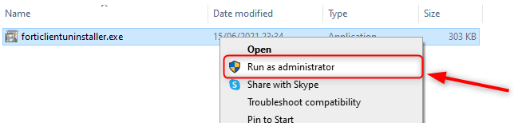Top of Form

Bottom of Form